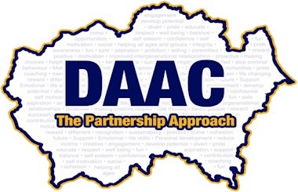
MINI POLICE
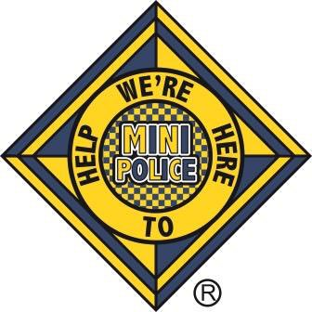

Information Pack
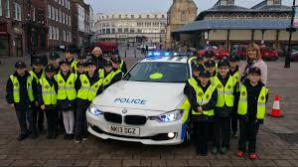
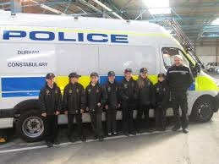

Mini Police Booklet Contents
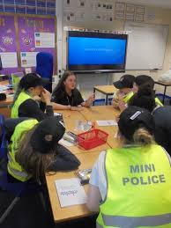
- Front Page
- Contents
- Mini Police
- 6-week Programme Outline
- 3-week Programme Outline
- One Off Session Outline
- Mini Police Uniform Details
- About our Visits
- Reward Scheme and Kennel Pals
- Ofsted
- NPT (Neighbourhood Policing teams) and Competitions
- My Mini Police Account Details

Mini Police
- The Mini Police scheme is an exciting opportunity for Year 5's, which follows our 3-step approach Education, Community and Reward.
The objective is to introduce a positive experience of policing and encourage develop involvement with their local community.
- Apprentice Youth Workers, aged 16-25 years old, use a peer to peer delivery method, deliver education on community and policing priorities which is then cascaded down to the rest of the school by the Mini Police themselves using a range a delivery methods.
- They will then become involved with community activities to enhance community confidence and pride including but not limited to litter picking, road, fire, water, safety and intergenerational opportunities.
- Visits – We facilitate a range of Mini Police visits.
- The digital platform encourages schools to continue the Mini Police concept in their environment it includes lesson plans, finding neighbourhood policing teams, sharing good practise and activities.it also allows you to access to our reward scheme, competitions and kennel pal’s information.

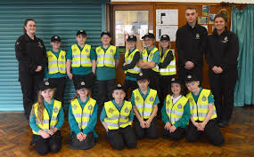

Available Programmes
We currently offer 3 types of programmes:
6 Week Programme
Week 1- About Me:
This involves the apprentices, employed by Durham Constabulary, getting to know the children we will be working with and building up rapport.
Week 1: Police awareness and the role of the Mini Police
- Mini Police can create own ideas of their role within the school
- What they think the role involves
- Mini Police to create their own profile
- Welcoming the Mini Police into the police family by getting their uniform
We will speak with your local neighbourhood policing teams and invite them to be involved.

Week 2- Education Session
We have numerous education topics on offer including; but not limited to
Environment, Road safety, Anti-social behaviour, Internet safety, Cyber bullying, Bullying, Water safety, Fire safety etc. The school choose the most beneficial for your community and pupils. If you have any engagement activities or suggestions please don’t hesitate to speak to us.
Week 3- Police Engagement
Mini Police pupils will be taught about police awareness opportunities including, learning the phonetic alphabet, discussing police uniform and try it on, crime scene investigation, police response levels etc.
Week 4 – Delivery Preparation
Mini Police will prepare and learn a script/activity/presentation based on the education topic chosen. This will be delivered to the rest of the school in a manner chosen by the school which could be assembly, leaflets, posters etc. pupils, staff, parents etc. may be invited as deemed appropriate in school.

Week 5 – Delivery
The delivery can be done in person/digitally/pre-recorded/posters/leaflets/information boards in school for the pupils to be able to present what they have been working on to other members of the school/community.

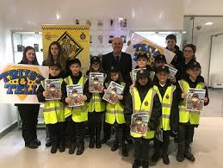
Week 6 – Community Event
The final week consists of doing a community event which can include but is not limited to:
- A litter pick around the school grounds
- A poster campaign for speeding or parking etc.
- Donating plant pots to local care homes/community centres etc.
Suggestions are welcome.
3 Week Programme

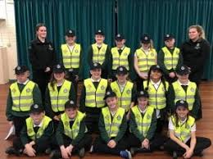
The 3-week programme will include: Week 1 – About me, Week 2 – Education session and Week 3 – Community event.

Single Sessions
For a Single session please choose from the below:
- In this session, the deliverers will do quick introductions/ice breakers. Different policing roles are to be covered briefly. The Mini Police will then create ideas of what they think their role is in school and what they should do regarding this role. The Mini Police receive their uniforms to show that they are part of the police family.

- Education session – topic of choice (see previous).

- Police engagement – topic of choice (see previous).

- We can run a session where we assist the Mini Police to prepare a session for delivery to the school/community (topic chosen).

- Community event can be chosen by the school.

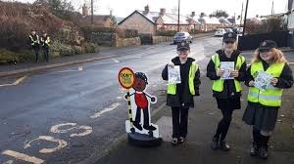

Mini Police Uniform

The uniform provided on initial set up of the scheme is a Mini Police Hat and High Viz jacket. These belong to the school for future use.
We do ask that the uniforms always stay in school for safeguarding reasons as the uniform does have the police badge on.
However, if you would like to continue to use them around the school at play times etc. that is your choice. If any extra uniform is required there will be a cost for the school.

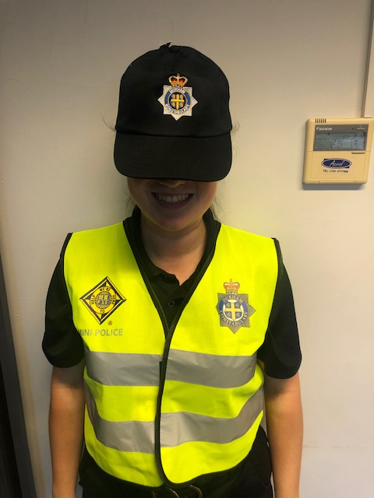

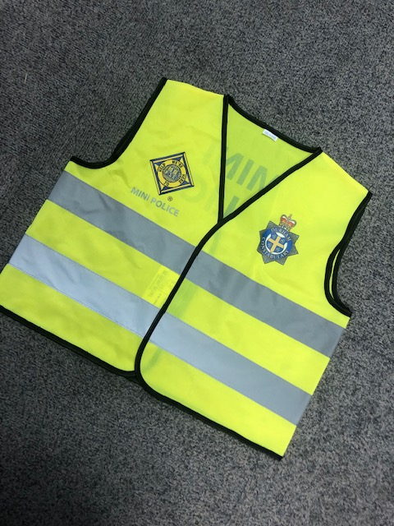
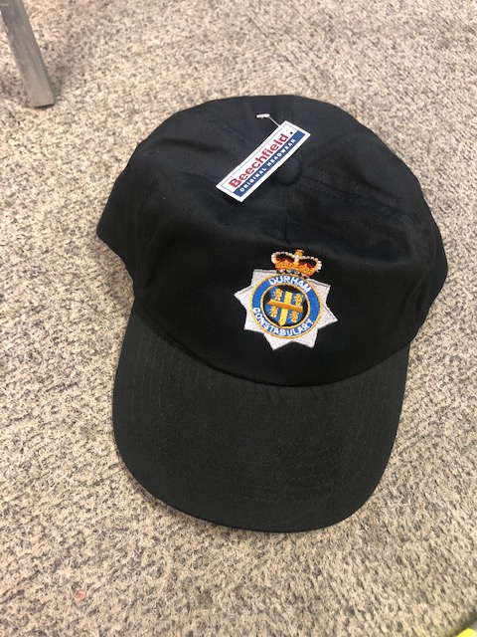

Mini Police Visits

- We provide a range of educational visits to Police/Community venues.
- We currently offer 3 visits per school, 1 visit per term.
- Visits – 1 hour in duration
- Visits currently provided: Police HQ, Police Custody Suite, Police Training Site (PSU), Police and Detectives Activity Visit, Dog Behaviour.
- We will provide the transport to and from the visits, we can seat max 15 children and 1 teacher.
- Book via website www.daac.org.uk - see overviews for full details about the visits on the website.

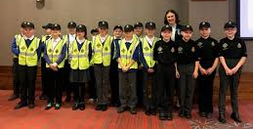

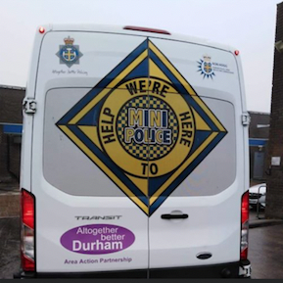
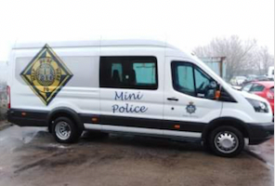

Reward Scheme
The Mini Police reward scheme allows schools to gain points for different activities such as events,
competitions and more. When points are gained your school will be able to work up the Mini Police ranking system. All school’s results will be published on our website– www.daac.org.uk
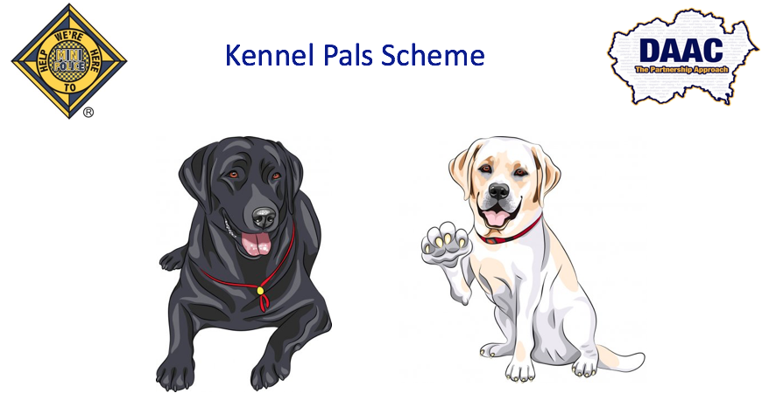
Kennel Pals

Kennel pals is a new scheme within the Mini Police programme. The Mini Police will receive tasks from their ‘Mini Police Pup’ and will complete tasks from the ‘Pupdates’. These tasks will result in the Mini Police gaining points – the points will add up and the Mini Police will go up on our Ranking System. The different stages of the ranking system will also allow the Mini Police to receive different prizes.

Mini Police Rank Structure:
- Begin as Mini Police – 0 points - Get a uniform
- Sergeant Mini Police – 50 points - Get a certificate and a Sergeant badge
- Inspector Mini Police – 100 points - Get a goodie bag and an Inspector badge
- Chief Inspector Mini Police – 150 points - Get to visit DAAC and get a Chief Inspector badge
- Superintendent Mini Police – 200 points - Get a good prize and Superintendent badge
- Chief Superintendent Mini Police – 250 points - Come to DAAC and complete a Police scenario and gain a Chief Superintendent badge
- Chief Constable Mini Police – 400 points - Meet the Chief/Executive and get an executive badge.

How to collect points:
Attend Police events – 25 points
Good behaviour during the Mini Police sessions and visits – 5 points
Attend a community event – 15 points
Attend a visit – 20 points
Completing a Kennel Pal task – 15 points per month
Posting about Mini Police on social media – 15 points
These points will be awarded by DAAC.

Ofsted
The Mini police programme involves several important responsibilities and duties inside and outside of school. It allows young people to engage with their communities, increase self-confidence, and attempts to remove any barriers between policing and young people.
EIF grade criteria: The curriculum extends beyond the academic, technical or vocational and provides for learners’ broader development, enabling them to develop and discover their interests and talents.
The curriculum and the provider’s wider work support learners to develop their character – including their resilience, confidence and independence – and help them know how to keep physically and mentally healthy.
At each stage of education, the provider prepares learners for future success in their next steps.
The provider prepares learners for life in modern Britain by: equipping them to be responsible, respectful, active citizens who contribute positively to society; developing their understanding of fundamental British values; developing their understanding and appreciation of diversity; celebrating what we have in common and promoting respect for the different protected characteristics as defined in law.

Neighbourhood Police Teams (NPT)
- The Mini Police can also assist the schools to be more involved with the community.
- Students/school will be encouraged to take part in community events which can be assisted/facilitated by your local Neighbourhood Policing Team.
- To help you utilise your Mini Police for relevant community/school/policing events etc.
Competitions
Mini Police are eligible to take part in numerous competitions involving prizes, activities and positive promotion of schools and students, such as,
- The Christmas bauble competition – the winning school gets to decorate the Christmas trees at Police HQ.
- The Easter card competition.
Competitions will be posted on our website/social media sites and digital platform.
- Competitions gain valuable points towards our reward scheme.

My Mini Police Account

We provide a My Mini Police Account. This allows you to use lesson plans/ideas if you wish to conduct yourselves after your programme is created, it offers ideas for many different activities. It also provides more information about all our educational visits that we offer to the Mini Police.
To access this please go to, www.daac.org.uk and click on the ‘my Mini Police Account’ button at the top right of the page. Then you enter your username and password (we will give you this information upon request). If you run into any problems, please let the DAAC staff know and we will assist you in starting up your Mini Police journey.
To sign up to the My Mini Police Account all you must do is,
- Go to the website as listed above
- Follow website direction, to the Mini Police page.
- Go to ‘My Mini Police Account’ located at the top right of the page.
- If you already have an account with us, enter the details. If unregistered or these details are unknown please contact us at enquiries@daac.org.uk
- This will then send an email to DAAC staff where we will create an account for your school and we will then send all of the information regarding the account back to you (the school).

